|  |
| --- |
| **BrewersBuddy** |
| Software Requirements Specification |
| SWENG 500 Team 3 |
|  |
| Geoff Blogref  Gregg Ideus  Jonathon Parise  John Pistorius  Steven Platz |
| **8/8/2013** |

|  |
| --- |
|  |

Table of Contents

1. Introduction 1

1.1 Purpose 1

1.2 Scope 1

2. General Description 1

2.1 Product Functions 1

2.2 User Characteristics 1

2.3 General Constraints 2

Brewers Buddy will need to comply with standards for software development and internet protocol. 2

2.4 Assumptions and Dependencies 2

3. Specific Requirements 2

3.1 Accounts 2

3.2 Log In/Out 4

3.3 Batches 4

3.4 Notes 6

3.5 Actions 6

3.6 Recipes 6

3.7 Measurement 7

3.8 Cellar 7

3.9 Rating 8

3.10 Search 9

3.11 Friend 9

3.12 Comment 9

4. Appendices 10

4.1 Applicable Standards, Regulations, Laws, etc. 10

4.2 Definitions, Acronyms, and Abbreviations 10

4.3 References 10

4.4 Any Other Ancillary Materials 11

# Introduction

## Purpose

The purpose of this document is to describe the requirement specifications for an internet-based tool for recording, tracking, and displaying information for beer and wine homebrewing.

## Scope

The purpose of the Brewers Buddy system is to create a convenient and easy to use online system for homebrewers to keep track of their home brewing. It allows homebrewers to enter and track recipes, batch information, and inventories for beer, mead, and wine.

It also provides a platform for brewers to share their recipes and batch information with other homebrew enthusiasts. Brewers are able to comment on, and rate, each other’s batches to create feedback and advice on what works well and how to improve future brews.

# General Description

## Product Functions

The major functions of Brewer Buddy are:

1. Provides beer and wine Homebrewers with an online tracking system accessible from any Internet-connected computer running modern operating systems and an Internet browser
2. Provides the user with an interface to register with the system
3. Records and displays a user’s homebrew recipes
4. Records and displays a user’s Batch information
5. Records and displays Notes, Actions, Measurements, Comments, and Ratings for a user’s Batches
6. Provides a platform for brewers to share their Recipes and Batch information with other registered users
7. Records and displays a user’s inventory of competed homebrew

## User Characteristics

The primary users of this application are homebrew hobbyists who would like to store Recipe, Batch, and Inventory information in a database and be able to share their information with other hobbyists. The experience level of users will vary from novice computer users to educated users who use computers on a daily basis. The users will also vary in homebrewing experience from beginners to advanced level brewers who have been homebrewing for years.

## General Constraints

## Brewers Buddy will need to comply with standards for software development and internet protocol.

## Assumptions and Dependencies

The homebrewer will need to provide a computer running modern operating systems. The computer will need to be connected to the internet and have an installed Internet browser.

# Specific Requirements

### Accounts

1. The system shall allow a new user to create an account (register).
2. The system shall require the user to enter their Username, Email Address, and Password for the account.
3. The system shall allow the user to optionally enter any of the following for the account: their First Name, Last Name, City, State, and Zip Code.
4. The system shall verify that the Username does not match the Username of any other registered user.
5. The system shall verify that the Email Address does not match the Email Address of any other registered user.
6. The system shall verify that the Zip Code is blank or is entered in the format ##### or #####-####.
7. The system shall require the Zip Code Value to be numeric.
8. The system shall verify that the State is blank or has exactly two characters.
9. The system shall require the State value to be upper case letters.
10. The system shall require the user to reenter the new Password a second time, and the system shall verify the two entered Passwords match.
11. The system shall not display the user-entered Password(s) on the screen in a readable format.
12. The system shall require the user Password to be not less than 6 characters.
13. The system shall require the Password to be any of the following characters: A-Z, a-z, 0-9, and the 32 special characters: ` ~ ! @ # $ % ^ & * ( ) - _ = + [ ] { } \ | ; : ‘ “ , . <> / ?
14. After a valid registration, the system shall automatically login the user.
15. The system shall allow the user to view their saved account information.
16. The information that can be viewed is Username, Email Address, First Name, Last Name, City, State, and Zip Code.
17. The system shall display the Username for the current user on each web page.

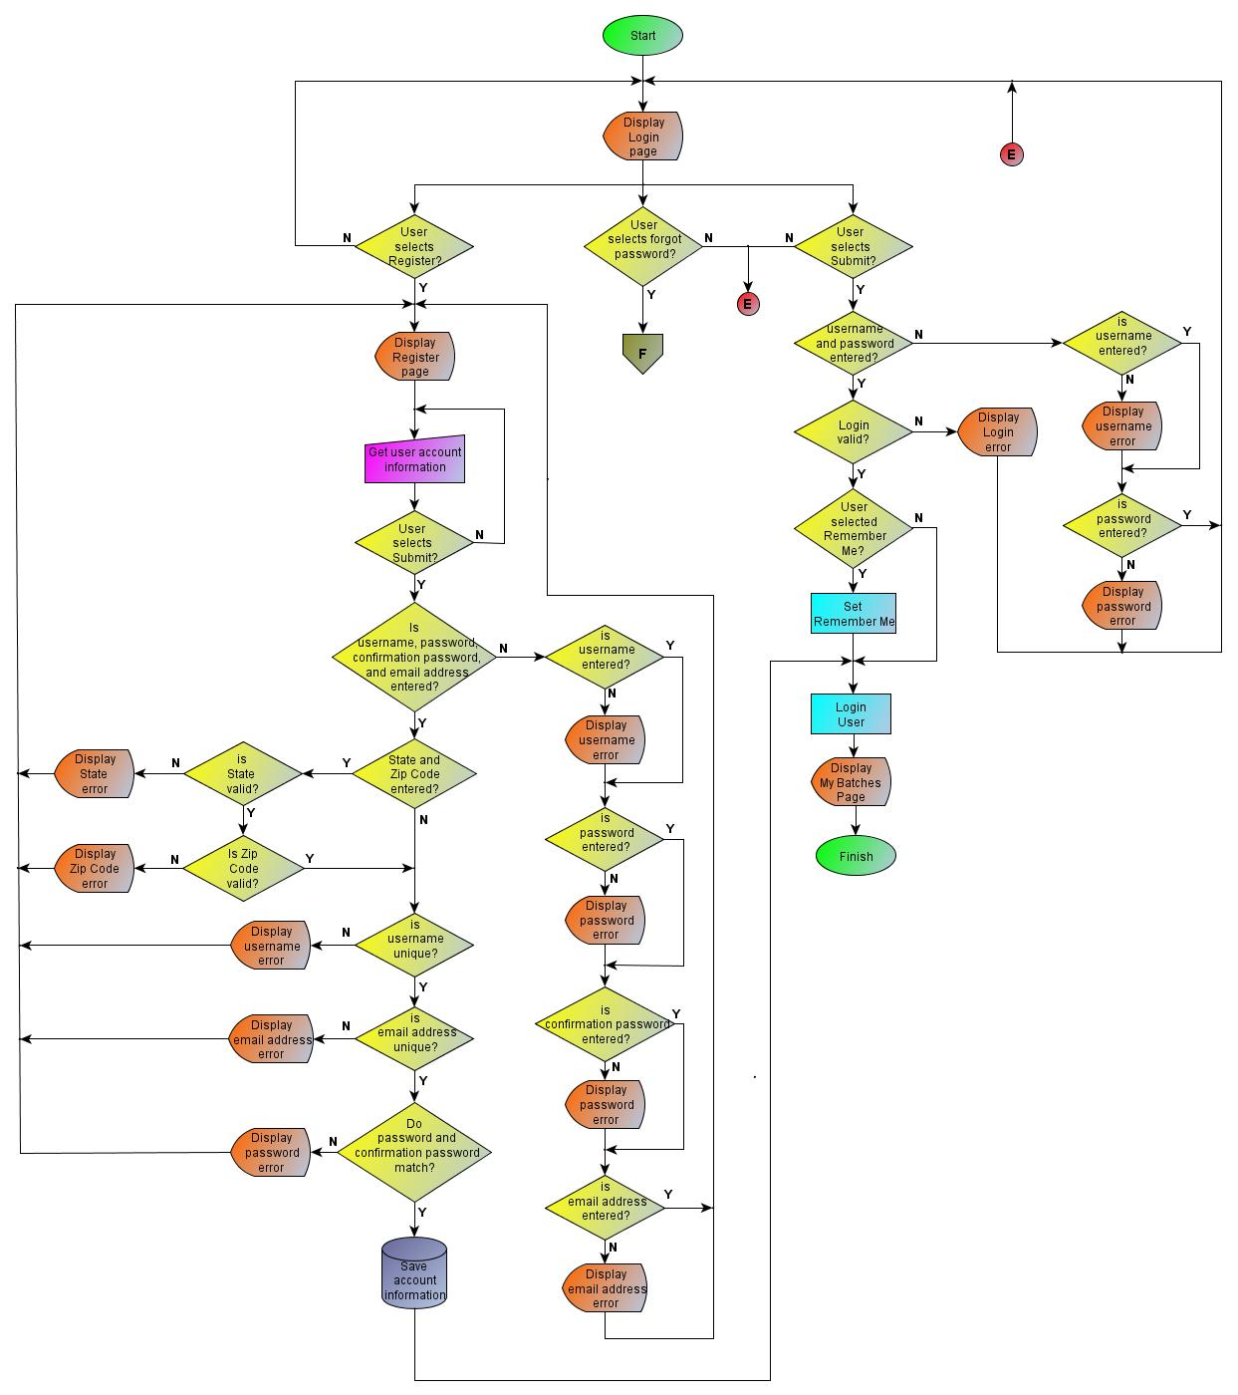

**Figure 1. Login and Register Pages**

1. The system shall allow the user to change their saved account information.
2. The information that can be changed is Password, Email Address, First Name, Last Name, City, State, and Zip Code.
3. When changing the user Password, the system shall require the user to enter the current Password, and then the new Password.
4. The system shall allow a user to delete their account.
5. The system shall prompt the user to verify they want the account deleted.
6. After a user verifies they want to delete their account, the system shall log the user out and delete their stored account information.
7. The system shall also delete any other information entered by that Username, such as Batches, Notes, Actions, Measurements, Ratings, Recipes, and Cellar Inventory.

### Log In/Out

1. The system shall allow a registered user to login to the system.
2. The system shall verify that a user enters a valid Username/Password combination.
3. If the user enters an invalid Username/Password combination, the system shall prompt the user to reenter a valid Username/Password combination.
4. The system shall not allow a user to access any web pages other than the login, registration, recover password, User’s Manual, and FAQ pages until they have successfully logged in.
5. The system shall allow a logged in user to logout of the system.
6. After logging out a user, the system shall display the login screen.
7. The system shall allow a registered user to request a new recover Password.
8. The system shall require the user to enter a valid Username.
9. The system shall generate a new random 8-digit recover Password.
10. The system shall send the new Recover Password to the Email Address listed in the user’s account information.
11. The system shall allow a user to select a “Remember Me” function when logging in.
12. The system shall store the user’s login credentials on the user’s computer.
13. The system shall automatically login the user when they connect to the system.
14. The system shall continue to “Remember” that user until the user selects logout.

### Batches

1. The system shall allow the user to create a new Batch.
2. The system shall require the user to enter a Name and Type.
3. The system shall record the Date and Time the Batch was created.
4. The system shall allow the user to optionally enter a Description.
5. The system shall allow the user to display a list of all their saved Batches.
6. The list shall include the Name, Date entered, Type, and Description for each Batch.
7. The system shall allow the user to display the details of a saved Batch.
8. The details shall include the Name of the Batch, Name of the Batch Owner, Date and Time entered, Type, and Description.
9. The system shall allow a user to edit any of their saved Batches.
10. The information that can be edited is the Name, Type, and Description.
11. The system shall allow a user to delete a saved Batch.
12. The system shall prompt the user to verify they want the Batch deleted.
13. The system shall also delete any other data associated with the Batch, such as Notes, Actions, Measurements, Comments, and Ratings.

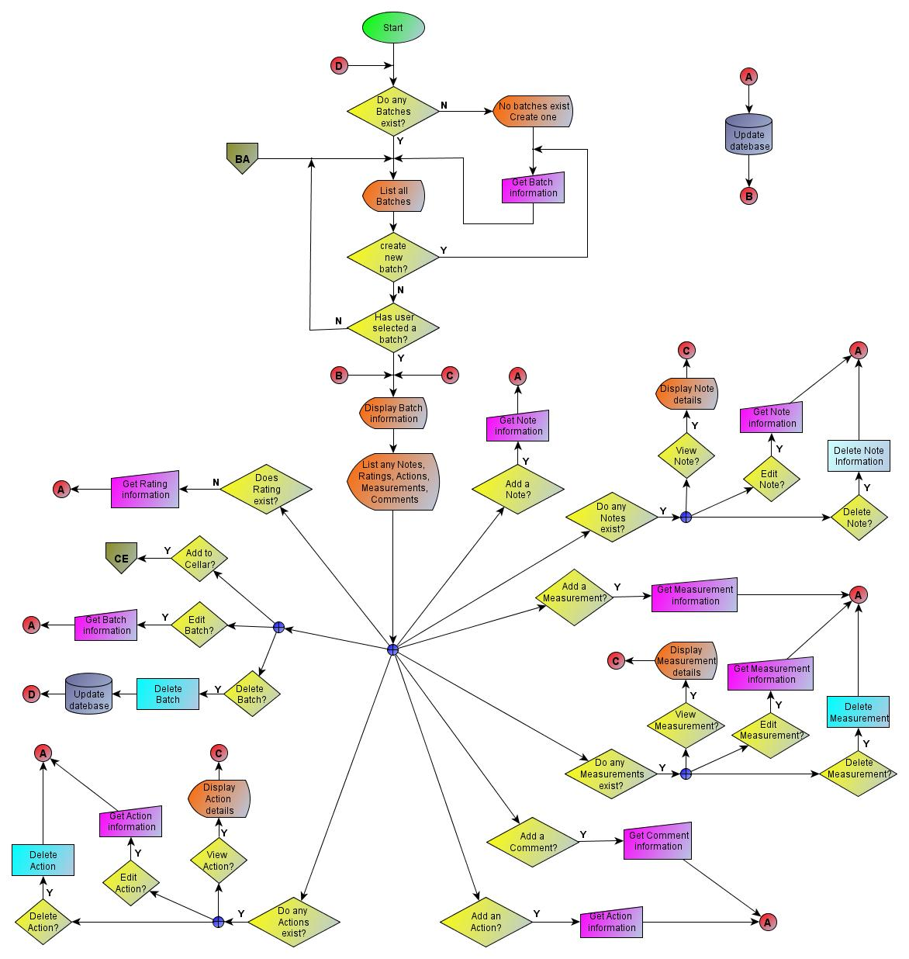

**Figure 2. My Batches Page**

### Notes

1. The system shall allow a user to add a Note about a Batch they created.
2. The system shall record the Date and Time the Note was created.
3. The system shall allow the user to optionally enter a Name and Description.
4. The system shall allow a user to display a list of all their saved Batch Notes.
5. The list shall include the Name and Description, for each Note.
6. The system shall allow a user to display the details of a saved Note.
7. The details shall include the Name, Date and Time entered, Description, and Author.
8. The system shall allow a user to edit any of their saved Batch Notes.
9. The information that can be edited is the Name and Description.
10. The system shall allow a user to delete a saved Batch Note.
11. The system shall prompt the user to verify they want the Note deleted.

### Actions

1. The system shall allow the user to add an Action to a Batch they created.
2. The system shall require the user to enter a Name, Type, and Description.
3. The system shall record the Date and Time the Action was created.
4. The system shall allow the user to display a list of all their saved Action for a Batch.
5. The list shall include the Name and Description for each Action.
6. The system shall allow the user to display the details of a saved Action.
7. The details shall include the Name, Date and Time entered, Description, and Performer of the Action.
8. The system shall allow a user to edit any of their saved Actions.
9. The information that can be edited is the Name, Type, Date and Time, and Description.
10. The system shall allow a user to delete a saved Action.
11. The system shall prompt the user to verify they want the Action deleted.

### Recipes

1. The system shall allow the user to create a new Recipe.
2. The system shall require the user to enter a Name.
3. The system shall record the Date the Recipe was created.
4. The system shall allow the user to optionally enter any of the following: Description, Preparation information, Process information, Finishing information, and Costs
5. The system shall allow the user to display a list of all their saved Recipes.
6. The list shall include the Name, Description, and the Date each Recipe was created.
7. The system shall allow the user to display the details of any of their saved Recipes.
8. The details shall include the Name, Owner, Date entered, Description, Preparation information, Process information, Finishing information, and Costs.
9. The system shall allow a user to edit the Name, Description, Preparation information, Process information, Finishing information, and Costs, for any of their saved Recipes.
10. The system shall allow a user to delete a saved Recipe.
11. The system shall prompt the user to verify they want the Recipe deleted.

### Measurement

1. The system shall allow a user to record a Batch Measurement.
2. The system shall require the user to enter a Measurement Value.
3. The system shall require the Measurement Value to be numeric.
4. The system shall record the Date and Time the Measurement was created.
5. The system shall allow the user to optionally enter a Name, Description, and what was measured.
6. The system shall allow the user to display a list of all their saved Measurements.
7. The list shall include the Name, Description, what was measured, and the Value.
8. The system shall allow the user to display the details of any of their saved Measurements.
9. The details shall include the Name, Date and Time entered, Description, what was measured, and the Value.
10. The system shall allow a user to edit any of their saved Measurements.
11. The information that can be edited is the Name, Date and Time entered, Description, what was measured, and the Value.
12. The system shall allow a user to delete any of their saved Batch Measurements.
13. The system shall prompt the user to verify they want the Measurement deleted.

### Cellar

1. The system shall allow a user to add a saved Batch to their Cellar Inventory.
2. The system shall require the user to enter the Name, container Type and Volume, and the Quantity of Container(s).
3. The system shall require the Volume value to be numeric.
4. The system shall require the Quantity value to be numeric.
5. The system shall allow the user to display a list of their entire Cellar Inventory.
6. The list shall include the Name, Quantity, Type and Volume of the Container(s).
7. The system shall allow the user to display the details of any of their saved Inventories.
8. The details shall include the Name, Quantity, Type and Volume of the Container(s), and the Batch from which the Inventory was created.
9. The system shall allow a user to edit any of their saved Inventories.
10. The information that can be edited is the Name, Quantity, Type and Volume.
11. The system shall allow a user to delete any of their saved Cellar Inventories.
12. The system shall prompt the user to verify they want the Inventory deleted.

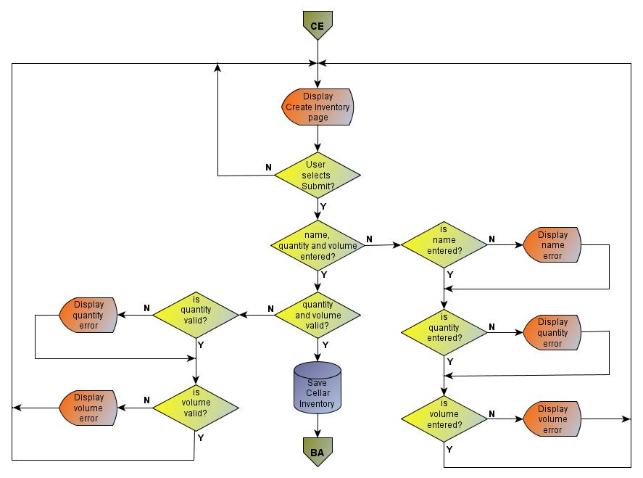

**Figure 3. Create Cellar Inventory Page**

### Rating

1. The system shall allow a user to Rate their saved Batch.
2. The system shall require the Rating to be from 0 to 100.
3. The system shall allow the user to optionally enter a Rating Comment.
4. The system shall only allow a user to enter a single Rating for a Batch.
5. The system shall display the Rater’s Rating for the Batch.
6. The system shall display a Rating of “N/A” if the Rater has not entered a Rating.
7. The system shall display the Average Rating for the Batch.
8. The Average Rating shall be the average of all Ratings for the Batch.
9. The system shall display an Average Rating of “N/A” if there are no Ratings.
10. The system shall allow the user to display a listing of all the Ratings for a Batch.
11. The listing shall include the Username, Rating, and Comment.

### Search

1. The system shall allow a user to Search for other users registered in the system.
2. The system shall allow a user to enter one or more of the following Search criteria: Username, First Name, Last Name, and Zip Code.
3. The system shall list users that match any of the entered criteria.
4. The list shall include the Username, First Name, Last Name, and Email Address.
5. The list shall not include the user performing the Search.

### Friend

1. The system shall allow a user to add another registered user as a “Friend”.
2. The system shall email the Friend request to the other user.
3. The system shall email the request to the Email Address of record.
4. The system shall allow the other user to accept the Friend request.
5. The other user shall not be added as a Friend until the user accepts the request.
6. The system shall allow the Friend of a user to display a list of all the user’s saved Batches.
7. The system shall not allow the Friend of a user to delete the user’s saved Batches.
8. The system shall allow the Friend of a user to display the details of the user’s saved Batches.
9. The system shall not allow the Friend of a user to edit the user’s batch information.
10. The system shall allow the Friend of a user to display a list of all Notes, Actions, Measurements, and Comments for the user’s saved Batch.
11. The system shall not allow the Friend of a user to delete the Notes, Actions, Measurements, and Comments for the user’s saved Batches.
12. The system shall allow the Friend of a user to display the details of all Notes, Actions, and Measurements for the user’s saved Batches.
13. The system shall not allow the Friend of a user to edit the user’s Notes, Actions, Measurements, and Comments.
14. The system shall allow the Friend of a user to add Comments to the user’s Batches.
15. The system shall allow the Friend of a user to Rate the user’s saved Batches.
16. The system shall allow the Friend of a user to display a listing of all the Ratings for the user’s saved Batch.
17. The system shall allow a user to remove a Friend.
18. The system shall allow the user to display a list of all their Friends.
19. The list shall include the Username, First Name, Last Name, and Email Address.

### Comment

1. The system shall allow a user to enter a Comment on their saved Batch.
2. The system shall require the Comment to be from 1 to 256 characters.
3. The system shall display a list of all Comments for a Batch.
4. The list shall include the Comment, Date and Time entered, and the Username of the user that entered the comment.

# Appendices

## Applicable Standards, Regulations, Laws, etc.

* IEEE STD 830-1998 IEEE Recommended Practice for Software Requirements Specifications. IEEE Computer Society, 1998

## Definitions, Acronyms, and Abbreviations

OG – Original Gravity

FG – Final Gravity

SP – Specific Gravity

ABV – Alcohol by Volume

FAQ – Frequently Asked Questions

SO₂ – Sulfur dioxide

pH – (Potential of Hydrogen) Acidity

## References

* Brewers Buddy User’s Manual
* Brewers Buddy Software Architecture Document (SAD/SDD)

## Any Other Ancillary Materials

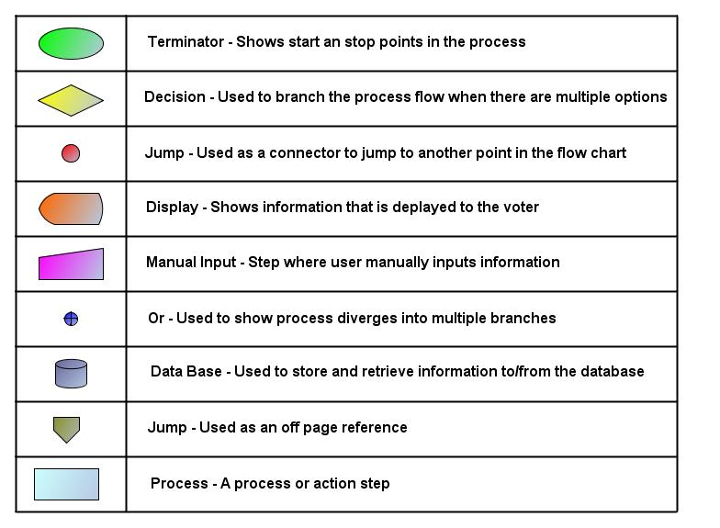

**Table 1. Flowchart Key**